MOSFET Turn ON in the Dark Light

Introduction

I saw this article about a BJT transistor turn ON in the dark light:

https://hackaday.io/page/7000-turn-on-in-the-darklight

I found a way to reduce the number of transistors after reading this article:

https://instructables.com/id/MOSFET-Touch-Lamp

My circuit can work for both bright LEDs and light bulbs. I have not made the circuit but I believe this circuit will work. The light enters the photodiode (represented as a current source in the circuit). The current across the current source begins to flow and the voltage across the photodiode falls to a lower value or zero. The Vg voltage that is entering the MOSFET transistor falls to zero, thus turning the MOSFET transistor OFF and the light source. The opposite happens when lights are turned OFF and the MOSFET transistor turns ON the bright LED.

Supplies

Parts: n-channel or p-channel MOSFET transistor, heat sink, bright LED or light bulb, photodiode/phototransistor, 47 kohm resistor (low power), matrix board, insulated wires, a metal wire (1 mm), power source (one AA/AAA/C/D battery for a 1.5 V light bulb or two AA/AAA/C/D for bright LED).

Tools: Wire stripper.

Optional parts: 1 nF ceramic or pillow capacitor, 1 Megohm resistor (low power), general-purpose diode, solder.

Optional tools: soldering iron, voltmeter, multimeter, AAA/AA/C/D battery harness, light bulb holder.

Step 1: Design the Circuit

I have drawn the circuit in PSpice simulation software version 9.1 student edition:
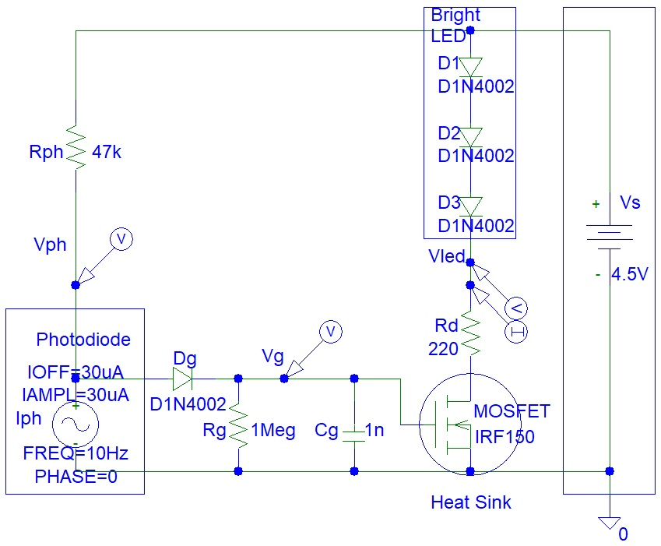
Figure 1: Design the Circuit.

Calculate the minimum Rph value to ensure saturation of the photodiode:

RphMin = Vs / Iph = 4.5 V / 100 uA
= 4.5 V / (100*10^-6) = 45,000 ohms = 45 kohms.
There are 39 kohm and 47 kohm in the E12 resistor series. However, I have chosen 47 kohm instead of 39 kohm because the maximum photodiode current could be a lot less than 100 uA and my circuit will not turn OFF the light source when the light source is dim.

The Dg diode is used to prevent the shorting of the Cg capacitor when a bright light source is applied to the photodiode because the photodiode saturates.

Calculate Rd value:

Rd = (Vs - Vled) / IledMax
= (4.5 V - 2 V) / 10 mA = 250 ohms

I have chosen 220 ohms. The Rd resistor is not essential if you are using a light bulb.

Calculate the maximum bandpass frequency for the MOSFET input:

Cfilter = 1 / (2⨯pi⨯Rg⨯Cg)
= 1 / (2⨯pi⨯1,000,000 ohms⨯(1⨯10^-9))
= 159.154943092 Hz

A human eye cannot see the change in light source brightness or colour if the light source input voltage fluctuates at frequencies of above 100 Hz.

You can replace the resistor (Rg) and capacitor (Cg) with an open circuit. You can also replace the diode (Dg) with a short circuit. Those three components are optional and should be used or omitted together, not separately.

The circuit can be also implemented with p-channel MOSFET. You simply turn the circuit upside down. You connect the p-channel MOSFET source pin to the power source and the drain pin to the Rd resistor. The p-channel MOSFET gate pin must be connected to Rg resistor. Instead of grounding the photodiode, Rg and Cg, the second pin of those components must be connected to the power source.

Step 2: Simulations

Simulations show that the circuit is working:

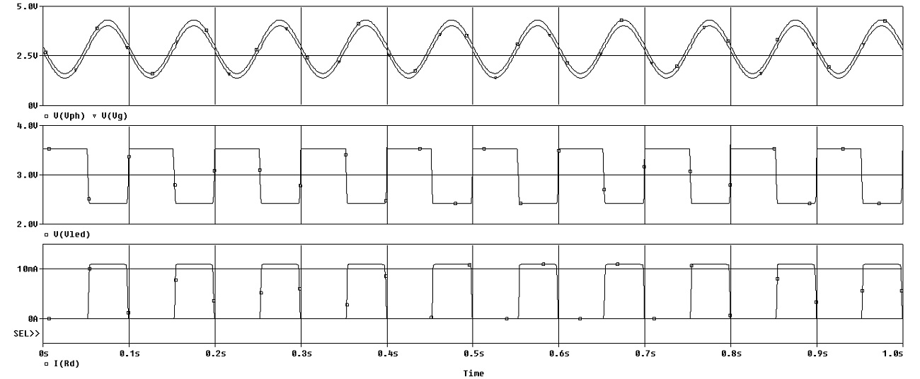
Figure 2: Simulations.

When I set the power supply voltage to 3 V, simulations show that the light source is not turning ON. This is because the gate voltage (MOSFET) input voltage is not high enough for the MOSFET to turn ON. The MOSFET did turn ON when I increased the power supply voltage from 3 V to 4.5 V. Therefore the problem can be solved by increasing the supply voltage to 4.5 V or even 6 V. You will need to connect a few bright LED or 1.5 V light bulbs in series or increase the Rd resistor value to prevent failure of your light bulbs or LEDs. Typical light bulbs need 300 mA and LEDs need 10 mA.

The circuit in this link shows that an n-channel MOSFET can turn ON with a gate voltage of just 3 V:

https://instructables.com/id/MOSFET-Touch-Lamp

You need to find the right MOSFET on the internet by checking the MOSFET specifications. You need to look at the graph for output MOSFET drain current versus MOSFET gate voltage.

Conclusion
I have not made the circuit yet but I will in the future and update this article.

