Bowl Bulbs

Introduciton

This article is about bowl bulbs that I designed.

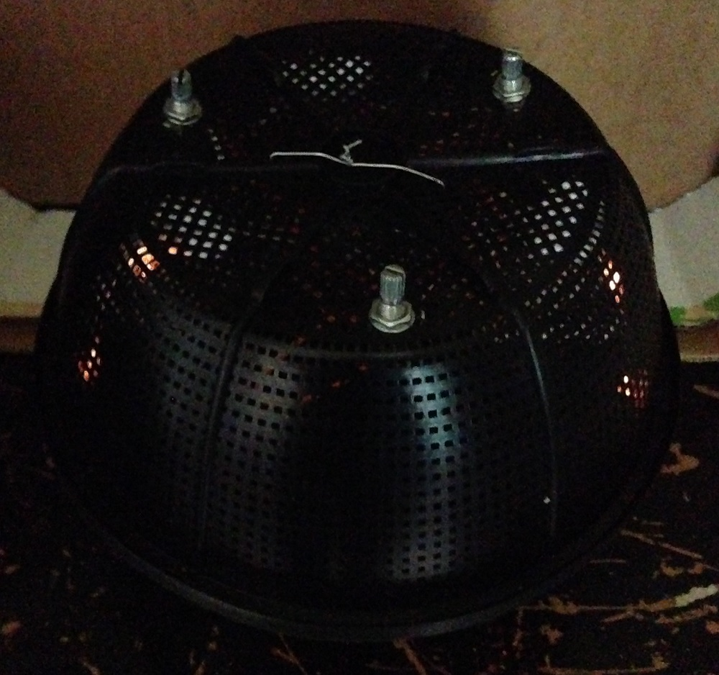
Figure 1: Light Bulb Toy.

I used a recycled Ricotta Cheese plastic bowl to save money on ordering a plastic box.

2. Step 1: Design the Circuit

The circuit is designed with three 1.5 V bulb miniature light bulbs.

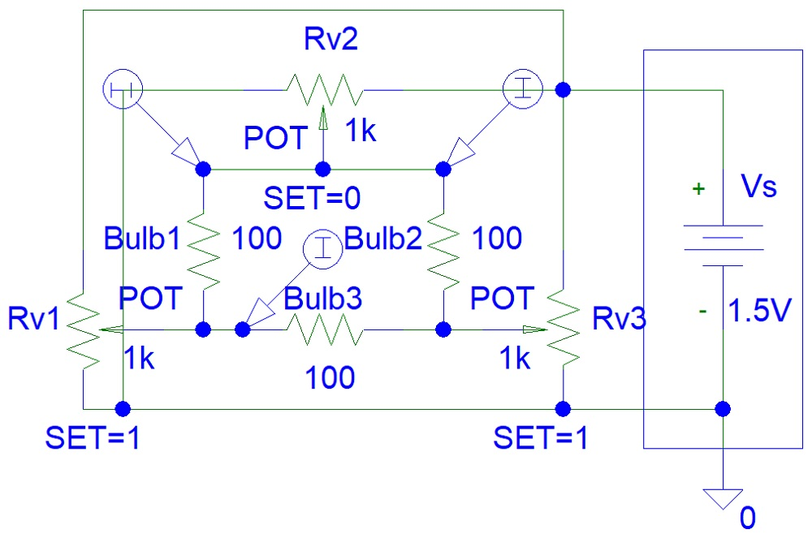
Figure 2: Circuit Design.

You can see that I used a 1.5 V battery in my design. You can try using a 3 V battery and bright LEDs with a 100 ohm resistor in series for each bright LED.

Step 2: Simulations

The old PSpice simulations software was quick to simulate the circuit.

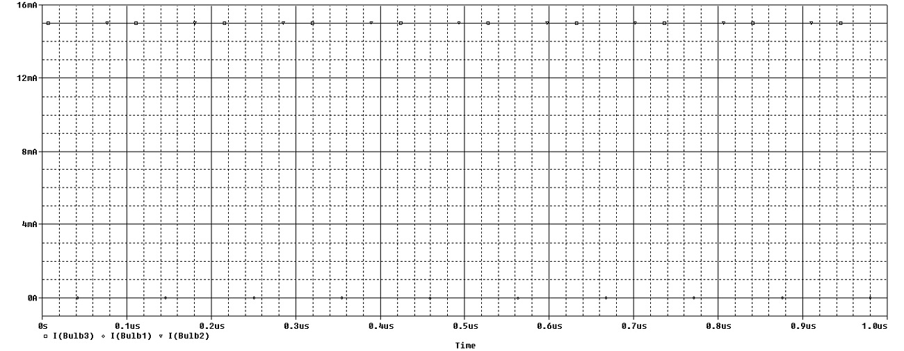
Figure 3: Simulations.

The maximum light bulb current (15 mA) depends on the light bulb resistance when ON and the potentiometer resistance.

Step 3: Make the Circuit

You can see that three bulbs are connected to three nodes in the circuit. However, because I used three 2 kohm dual gang potentiometers, each bulb is isolated from the other two bulbs.

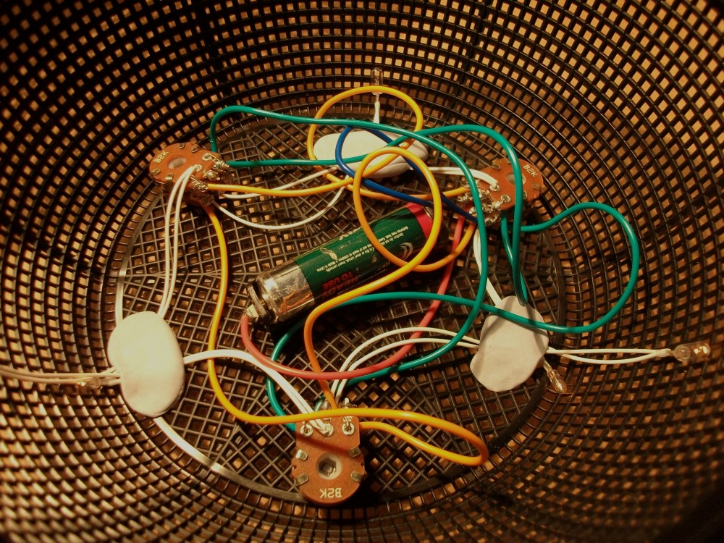
Figure 4: Make the Circuit.

You can try using a 1 kohm single gang potentiometer as shown in my circuit, connecting all three light bulbs together and see what happens.

Step 4: Testing

Testing the circuit involved finding bad joints. I tried to avoid using my soldering iron. However, in the end I soldered the light bulb connections to potentiometers only and not the power supply connections to potentiometers.

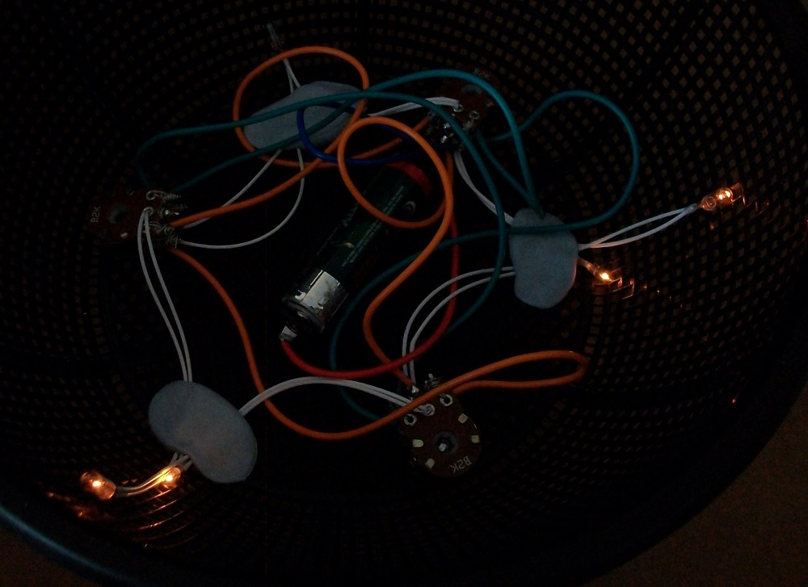
Figure 5: Testing.

Conclusion

This is my final outcome of this minor project:

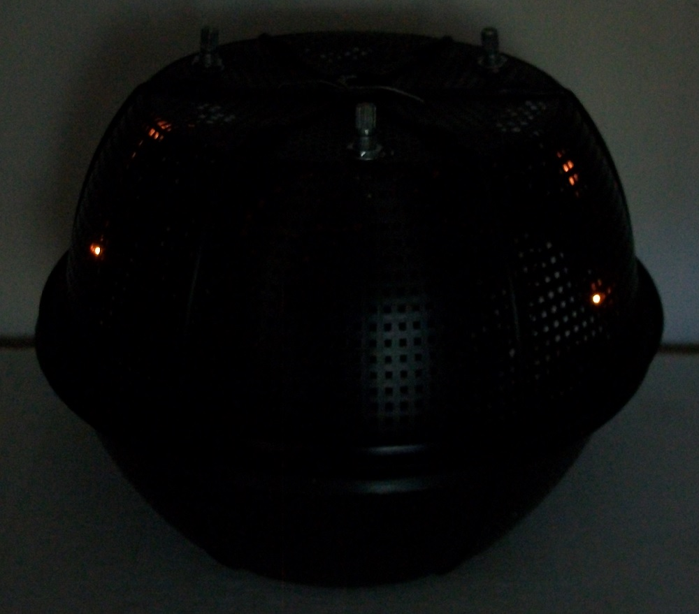
Figure 6: Finished Device.

